Computational Techniques 2023

Abbas went sicko mode fr

If you want to do anything with matrices in this document, right click on the document and select Open > Open in app (the Word app allows you to do proper matrices and stuff, don’t try and do it in Word online for your own sake pls ty)

1ai)

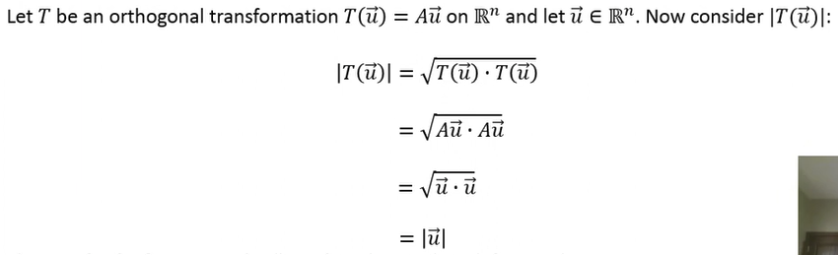

Source: <https://www.youtube.com/watch?v=2aGzWwmN6kg>

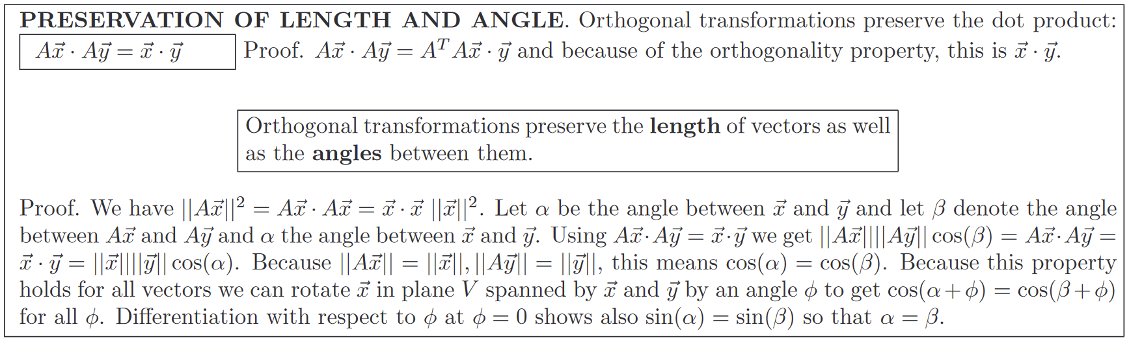Source: <https://people.math.harvard.edu/~knill/teaching/math21b2008/handouts/orthomatrix.pdf>

1bi) <https://www.emathhelp.net/en/calculators/linear-algebra/svd-calculator/?i=%5B%5B1%2C0%5D%2C%5B1%2C1%5D%2C%5B0%2C1%5D%5D>

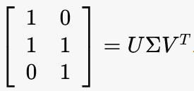

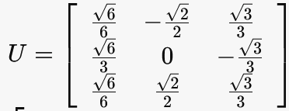

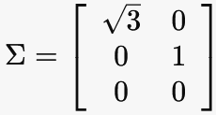

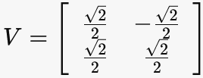

1ci) <https://www.omnicalculator.com/math/qr-decomposition>

A = QR, where:

Q = 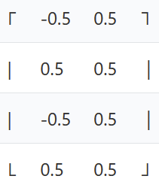 R = 

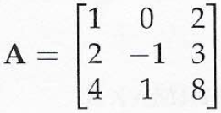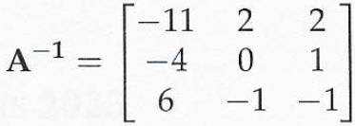

**K(A) with linf norm:**

||A-1||inf = max(11 + 2 + 2, 4 + 0 + 1, 6 + 1 + 1) = max(13, 5, 8) = 13

||A||inf = max(1 + 0 + 2, 2 + 1 + 3, 4 + 1 + 8) = max(3 + 6 + 13) = 13

K(A)inf = 13 * 13 = 169

**K(A) with l1 norm:**

||A-1||1 = max(11 + 4 + 6, 2 + 0 + 1, 2 + 1 + 1) = max(21, 3, 4) = 21

||A||1 = max(1 + 2 + 4, 0 + 1 + 1, 2 + 3 + 8) = max(7, 2, 13) = 13

K(A)1 = 21 * 13 = 273

2aii) Power method:

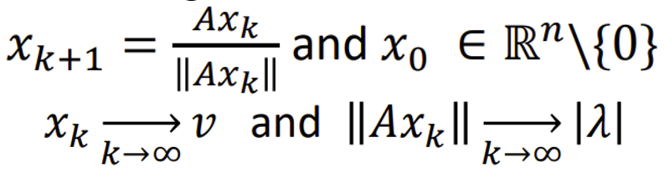

I believe Pancham mentioned that we should use the linf norm for power iteration, so that’s what I used in the exam. I know some people used l2, but I’ll use linf here. Ugly numbers either way tbh

$$x_{0}=\left[\begin{matrix}1 \\ 1 \\ 1\end{matrix}\right]$$

$$A=\left[\begin{matrix}1 & 0 & 2 \\ 2 & -1 & 3 \\ 4 & 1 & 8\end{matrix}\right]$$

Iteration 1:

$${Ax}_{0}= \left[\begin{matrix}1 & 0 & 2 \\ 2 & -1 & 3 \\ 4 & 1 & 8\end{matrix}\right] × \left[\begin{matrix}1 \\ 1 \\ 1\end{matrix}\right]= \left[\begin{matrix}3 \\ 4 \\ 13\end{matrix}\right]$$

$$\left\|{Ax}_{0}\right\|= \max\left(3, 4, 13\right)=13$$

$$x_{1}=\frac{1}{13} × \left[\begin{matrix}3 \\ 4 \\ 13\end{matrix}\right]$$

Iteration 2:

$${Ax}_{1}=\left[\begin{matrix}1 & 0 & 2 \\ 2 & -1 & 3 \\ 4 & 1 & 8\end{matrix}\right] × \frac{1}{13} × \left[\begin{matrix}3 \\ 4 \\ 13\end{matrix}\right]= \frac{1}{13} ×\left[\begin{matrix}29 \\ 41 \\ 120\end{matrix}\right]$$

$$\left\|{Ax}_{1}\right\|= \max\left(29, 41, 120\right)=120$$

$$x_{2}=\frac{1}{13} × \frac{1}{120} × \left[\begin{matrix}29 \\ 41 \\ 120\end{matrix}\right]= \frac{1}{1560} × \left[\begin{matrix}29 \\ 41 \\ 120\end{matrix}\right]$$

Iteration 3:

$${Ax}_{2}=\left[\begin{matrix}1 & 0 & 2 \\ 2 & -1 & 3 \\ 4 & 1 & 8\end{matrix}\right] × \frac{1}{1560} × \left[\begin{matrix}29 \\ 41 \\ 120\end{matrix}\right]= \frac{1}{1560} ×\left[\begin{matrix}269 \\ 377 \\ 1117\end{matrix}\right]$$

$$\left\|{Ax}_{2}\right\|= \max\left(269, 377, 1117\right)=1117$$

$$x_{3}=\frac{1}{1560} × \frac{1}{1117} × \left[\begin{matrix}269 \\ 377 \\ 1117\end{matrix}\right]= \frac{1}{1742520} × \left[\begin{matrix}269 \\ 377 \\ 1117\end{matrix}\right]$$

Rayleigh Quotient:

I think people who did the l2 norm way got around a 10 as their answer for the Rayleigh Quotient?

2c) IT WAS LITERALLY THE DEFAULT PROBLEM ON THE WEBSITE 😭

<https://cbom.atozmath.com/CBOM/Simplex.aspx?q=sm>

